Association Rule Learning – Apriori Intuition

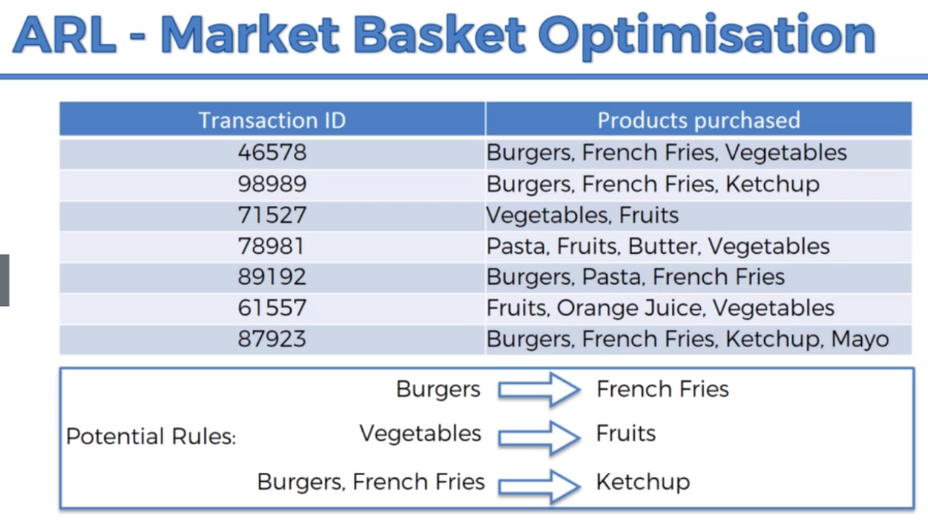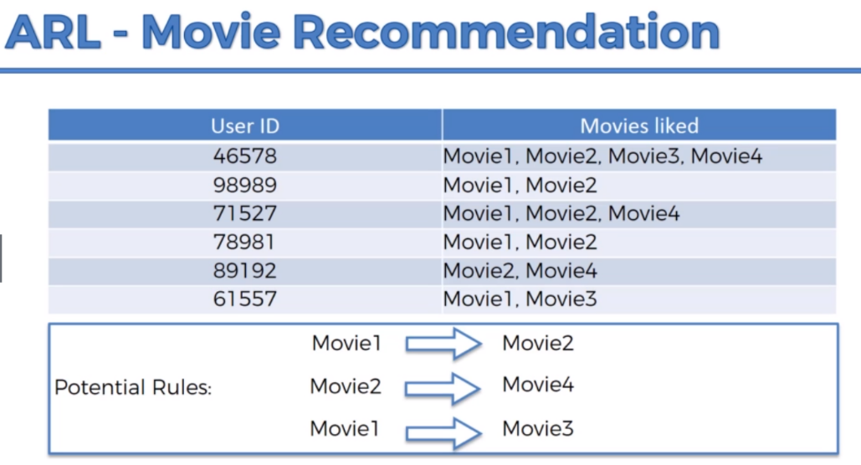People who bought also bought something else. Associated Rule Learning, Things come in Pairs or Triplets

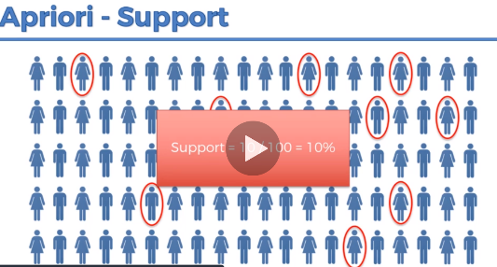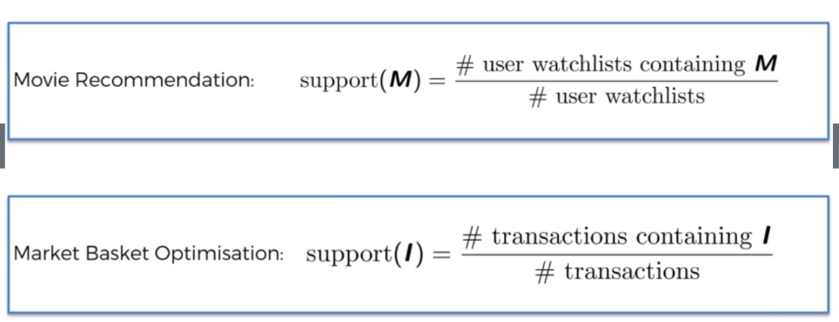Apriori Part 1– Support

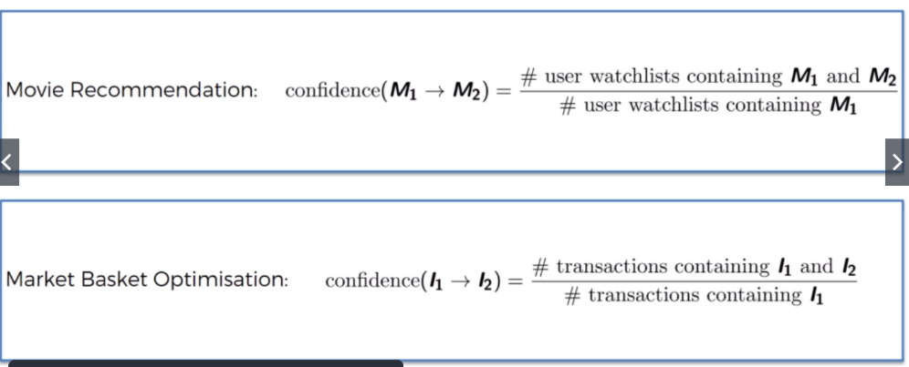Apriori Part 2 – Confidence (we are testing a rule/hypothesis)

Burgers and French Fries

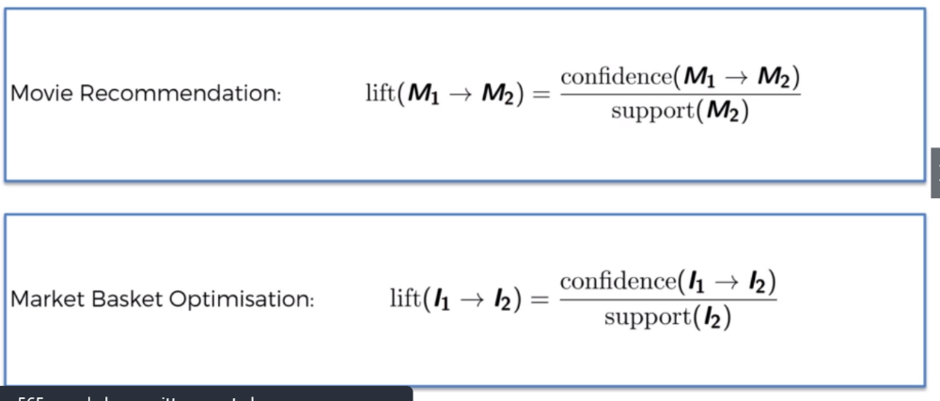Apriori Part 3 – Lift (Confidence divided by Support

Apriori – Algorithm (Slow algorithm)

Step1: Set a minimum support and confidence

Step2: Take all the subsets in transactions having higher support than minimum support

Step3: Take all the rules of these subsets having higher confidence than minimum confidence

Step4: Sort the rules by decreasing lift. Rule with highest lift is the Strongest lift.